# DAILY ASSESSMENT

|  |  |  |  |
| --- | --- | --- | --- |
| Date: | 15/07/2020 | Name: | Chesmi B R |
| Course: | **Computer vision basics** | USN: | 4AL16EC100 |
| Topic: | **Week 3: low, mid and high level vision** | Semester & Section: | 8TH SEM & A Section |
| Github Repository: | chesmibr |  |  |

|  |
| --- |
| **FORENOON SESSION DETAILS** |

# imgradient

Gradient magnitude and direction of 2-D image

## Syntax

[[Gmag,Gdir] = imgradient(I)](https://in.mathworks.com/help/images/ref/imgradient.html#d120e129446)

[[Gmag,Gdir] = imgradient(I,method)](https://in.mathworks.com/help/images/ref/imgradient.html#d120e129473)

[[Gmag,Gdir] = imgradient(Gx,Gy)](https://in.mathworks.com/help/images/ref/imgradient.html#d120e129495)

## Description

[[Gmag](https://in.mathworks.com/help/images/ref/imgradient.html" \l "bthgcil-Gmag),[Gdir](https://in.mathworks.com/help/images/ref/imgradient.html#bthgcil-Gdir)] = imgradient([I](https://in.mathworks.com/help/images/ref/imgradient.html#bthgcil-I)) returns the gradient magnitude, Gmag, and the gradient direction, Gdir, of the 2-D grayscale or binary image I.

You optionally can compute the gradient magnitude and direction using a GPU (requires Parallel Computing Toolbox™).

[[Gmag](https://in.mathworks.com/help/images/ref/imgradient.html" \l "bthgcil-Gmag),[Gdir](https://in.mathworks.com/help/images/ref/imgradient.html#bthgcil-Gdir)] = imgradient([I](https://in.mathworks.com/help/images/ref/imgradient.html" \l "bthgcil-I),[method](https://in.mathworks.com/help/images/ref/imgradient.html#bthgcil-method)) returns the gradient magnitude and direction using the specified method.

[[Gmag](https://in.mathworks.com/help/images/ref/imgradient.html" \l "bthgcil-Gmag),[Gdir](https://in.mathworks.com/help/images/ref/imgradient.html#bthgcil-Gdir)] = imgradient([Gx](https://in.mathworks.com/help/images/ref/imgradient.html" \l "bthgcil-Gx),[Gy](https://in.mathworks.com/help/images/ref/imgradient.html#bthgcil-Gy)) returns the gradient magnitude and direction from the directional gradients Gx and Gy in the x and y directions, respectively.

## Examples

[collapse all](javascript:void(0);)

### Calculate Gradient Magnitude and Direction Using Prewitt Method

Try This Example

[View MATLAB Command](matlab:openExample('images/CalculateGradientMagnitudeAndGradientDirectionExample'))

Read an image into workspace.

I = imread('coins.png');

Calculate the gradient magnitude and direction, specifying the Prewitt gradient operator.

[Gmag, Gdir] = imgradient(I,'prewitt');

Display the gradient magnitude and direction.

figure

imshowpair(Gmag, Gdir, 'montage');

title('Gradient Magnitude, Gmag (left), and Gradient Direction, Gdir (right), using Prewitt method')

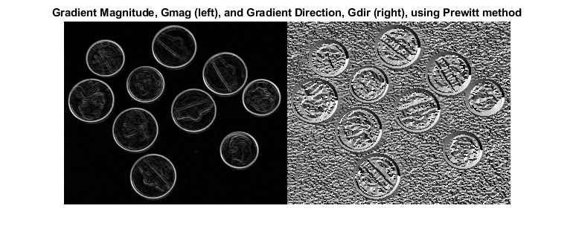

Read an image into workspace.

I = imread('coins.png');

Calculate the x- and y-directional gradients. By default, imgradientxy uses the Sobel gradient operator.

[Gx,Gy] = imgradientxy(I);

Display the directional gradients.

imshowpair(Gx,Gy,'montage')

title('Directional Gradients Gx and Gy, Using Sobel Method')

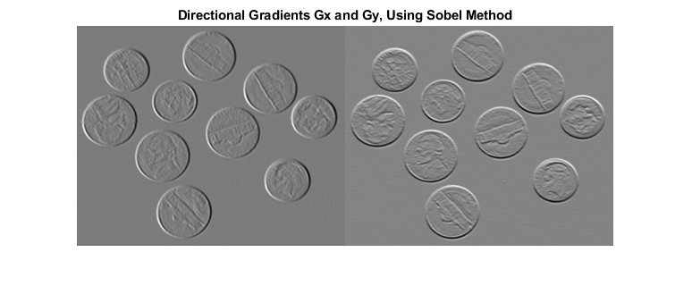

Calculate the gradient magnitude and direction using the directional gradients.

[Gmag,Gdir] = imgradient(Gx,Gy);

Display the gradient magnitude and direction.

imshowpair(Gmag,Gdir,'montage')

title('Gradient Magnitude (Left) and Gradient Direction (Right)')

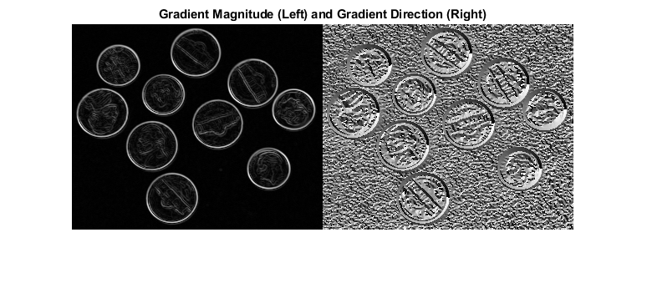

## Input Arguments

[collapse all](javascript:void(0);)

### I — Input image 2-D grayscale image | 2-D binary image

Input image, specified as a 2-D grayscale or 2-D binary image.

**Data Types:**single | double | int8 | int32 | uint8 | uint16 | uint32 | logical

### method — Gradient operator 'sobel' (default) | 'prewitt' | 'central' | 'intermediate' | 'roberts'

Gradient operator, specified as one of the following values.

**Data Types:**char | string

### Gx — Horizontal gradient numeric matrix

Horizontal gradient, specified as a numeric matrix. The horizontal (x) axis points in the direction of increasing column subscripts. You can use the [imgradientxy](https://in.mathworks.com/help/images/ref/imgradientxy.html) function to calculate Gx.

**Data Types:**single | double | int8 | int32 | uint8 | uint16 | uint32

### Gy — Vertical gradient numeric matrix

Vertical gradient, specified as a numeric matrix of the same size as [Gx](https://in.mathworks.com/help/images/ref/imgradient.html#bthgcil-Gx). The vertical (y) axis points in the direction of increasing row subscripts. You can use the [imgradientxy](https://in.mathworks.com/help/images/ref/imgradientxy.html) function to calculate Gy.

**Data Types:**single | double | int8 | int32 | uint8 | uint16 | uint32

## Output Arguments

[collapse all](javascript:void(0);)

### Gmag — Gradient magnitude numeric matrix

Gradient magnitude, returned as a numeric matrix of the same size as image [I](https://in.mathworks.com/help/images/ref/imgradient.html#bthgcil-I) or the directional gradients [Gx](https://in.mathworks.com/help/images/ref/imgradient.html#bthgcil-Gx) and [Gy](https://in.mathworks.com/help/images/ref/imgradient.html" \l "bthgcil-Gy). Gmag is of class double, unless the input image or directional gradients are of class single, in which case it is of class single.

**Data Types:**double | single

### Gdir — Gradient direction numeric matrix

Gradient direction, returned as a numeric matrix of the same size as gradient magnitude [Gmag](https://in.mathworks.com/help/images/ref/imgradient.html" \l "bthgcil-Gmag). Gdir contains angles in degrees within the range [-180, 180] measured counterclockwise from the positive x-axis. (The x-axis points in the direction of increasing column subscripts.) Gdir is of class double, unless the input image [I](https://in.mathworks.com/help/images/ref/imgradient.html#bthgcil-I) or directional gradients are of class single, in which case it is of class single.

**Data Types:**double | single

## Tips

* When applying the gradient operator at the boundaries of the image, values outside the bounds of the image are assumed to equal the nearest image border value. This is similar to the 'replicate' boundary option in [imfilter](https://in.mathworks.com/help/images/ref/imfilter.html).

## Algorithms

The algorithmic approach taken in imgradient for each of the listed gradient methods is to first compute directional gradients, [Gx](https://in.mathworks.com/help/images/ref/imgradient.html#bthgcil-Gx) and [Gy](https://in.mathworks.com/help/images/ref/imgradient.html" \l "bthgcil-Gy), in the x and y directions, respectively. The horizontal (x) axis points in the direction of increasing column subscripts. The vertical (y) axis points in the direction of increasing row subscripts. The gradient magnitude and direction are then computed from their orthogonal components Gx and Gy.

imgradient does not normalize the gradient output. If the range of the gradient output image has to match the range of the input image, consider normalizing the gradient image, depending on the [method](https://in.mathworks.com/help/images/ref/imgradient.html#bthgcil-method) argument used. For example, with a Sobel kernel, the normalization factor is 1/8, for Prewitt, it is 1/6, and for Roberts it is ½.

**DAILY ASSESSMENT**

|  |  |  |  |
| --- | --- | --- | --- |
| **Date:** | **15/07/2020** | **Name:** | **Chesmi B R** |
| **Course:** | **Trailhead salesforce developer** | **USN:** | **4AL16EC100** |
| **Topic:** | **Platform development basics** | **Semester & Section:** | **8TH SEM & A Section** |
| **Github Repository:** | **chesmibr** |  |  |

|  |
| --- |
| **AFTERNOON SESSION DETAILS** |
|  |

|  |
| --- |
| **Report**-  At Salesforce, we group our services by clouds. There’s Sales Cloud for CRM, Service Cloud for customer support, and a handful of other clouds that help companies support their business functions. And while each of these clouds serves a unique purpose, there’s one thing they all have in common: the power of the Salesforce platform.  What is the Salesforce platform, exactly?  Like any platform, the Salesforce platform is a group of technologies that supports the development of other technologies on top of it. What makes it unique is that the platform supports not only all the Salesforce clouds, but it also supports custom functionality built by our customers and partners. This functionality ranges from simple page layouts to full-scale applications.  If you’re here today, we’re assuming you know a bit about software development. Throughout this module, we’re going to give you an overview of development on the Salesforce platform. We talk about some of the pillars of Salesforce development and how they work together to create a robust system. We even touch on some common questions that developers new to the platform run into as they get started.  Before we continue, let’s make sure we’re on the same page. If you’re brand new to Salesforce and you haven’t completed the [Salesforce Platform Basics module](https://trailhead.salesforce.com/modules/starting_force_com), we suggest you do that before you keep reading.  Once you’re done with that, you’re ready to get started! Platform Building Blocks As we mentioned, the platform not only forms the foundation of core Salesforce products like Sales Cloud and Service Cloud, but it also lets you build your own functionality. Building your own functionality can mean customizing existing Salesforce offerings or it can mean building something from scratch.  Let’s focus on that latter part and talk about what the Salesforce platform offers developers.  Our core platform lets you develop custom data models and applications for desktop and mobile. And with the platform behind your development, you can build robust systems at a rapid pace.  And then there’s the Heroku platform. Heroku gives developers the power to build highly scalable web apps and back-end services using Python, Ruby, Go, and more. It also provides database tools to sync seamlessly with data from Salesforce.  And then there’s the host of Salesforce APIs. These let developers integrate and connect all their enterprise data, networks, and identity information.  And then there’s the Mobile SDK. The Mobile SDK is a suite of technologies that lets you build native, HTML5, and hybrid apps that have the same reliability and security as the Salesforce app.  And then... wait. Let’s stop for a second.  The problem with the platform and all its parts is that listing them out takes a really long time. And just talking about them doesn’t help you understand everything they do. Let’s take a different approach and talk about what we can do with the platform. Or, more precisely, what we can build with it.  The DreamHouse App  Let’s float a scenario. Throughout the rest of this module, we use this scenario to explore the many exciting tools and technologies that the Salesforce platform provides.  You’re a developer for DreamHouse Realty, a company that aggregates real estate listings to better connect homebuyers and real estate agents. Your boss asks you to build a new system to track real estate listings. Your internal employees will use it to track and communicate about properties. Your partner real estate brokers will use it to access information about customers. And your customers will view properties and contact brokers for viewings.  Building an app like this one from scratch isn’t an easy thing to do. Taking on this project in real life can involve a long, complicated list of functional requirements and the implementation of special integrations for your company’s business data. Working by yourself, it can take you months to get something out the door.  But before your stress builds and you melt into a puddle of existential dread, remember: You’ve got the platform. And building complex business applications at a breakneck pace is what the platform’s all about.  We’re going to show you a fully functional version of the DreamHouse app so you can get a feel for how it was built. As we move through, we discuss important Salesforce development concepts using the app to guide us. Install the DreamHouse App To follow along and practice the steps in this module, you need to install the DreamHouse package in your Trailhead Playground. Follow the instructions here to launch a playground and install the package. You also use this package and playground when it’s time to complete the hands-on challenge.  Launch your Trailhead Playground by scrolling to the bottom of this page and clicking **Launch**. If you see a tab in your org labeled Install a Package, great. Follow the steps below.  If not, from the App Launcher (App Launcher icon), find and select **Playground Starter** and follow the steps. If you don’t see the Playground Starter app, copy [this package installation link](https://login.salesforce.com/packaging/installPackage.apexp?p0=04tB00000009UeX) and check out [Install a Package or App to Complete a Trailhead Challenge](https://trailhead.salesforce.com/help?article=Installing-a-package-or-app-to-complete-a-Trailhead-challenge) on Trailhead Help.   1. Click the Install a Package tab. 2. Paste 04tB00000009UeX into the field. 3. Click **Install**. 4. Select **Install for All Users**, then click **Install**. |